Christopher King
2018141521058
Applied Fluid Mechanics
Class Section 01
03/16/2021

Problem 8.3
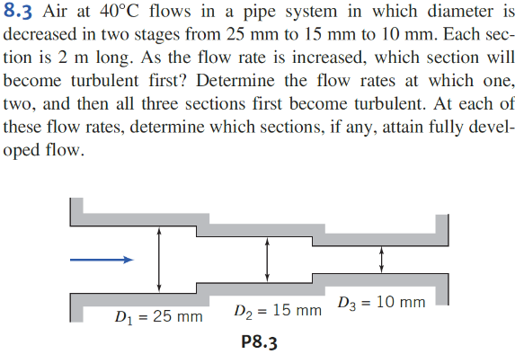
$$Q_{1}=\frac{{Re}_{crit}πvD_{1}}{4}$$
$$Q_{2}=\frac{{Re}_{crit}πvD_{2}}{4}$$
$$Q_{3}=\frac{{Re}_{crit}πvD_{3}}{4}$$
$$L_{laminer}=0.06ReD, Turbulent:L_{min}=25D L_{max}=40D$$
$$Q_{3}:$$
$$L_{min,3}=25D_{3} L_{max,3}=40D_{3}$$
$$L_{laminer,3}=0.06\left(\frac{4Q_{3}}{πvD_{3}}\right)D_{3},$$
$$L_{laminer,2}=0.06\left(\frac{4Q_{3}}{πvD_{2}}\right)D_{2}$$
$$L_{laminer,1}=0.06\left(\frac{4Q_{3}}{πvD_{1}}\right)D_{1}$$
$$Q_{2}:$$
$$L_{min,3}=25D_{3} L_{max,3}=40D_{3}$$
$$L_{min,2}=25D_{2} L_{max,2}=40D_{2}$$
$$L_{laminer,2}=0.06\left(\frac{4Q_{2}}{πvD_{2}}\right)D_{2}$$
$$L_{laminer,1}=0.06\left(\frac{4Q_{2}}{πvD_{1}}\right)D_{1}$$
$$Q_{1}:$$
$$L_{min,3}=25D_{3} L_{max,3}=40D_{3}$$
$$L_{min,2}=25D_{2} L_{max,2}=40D_{2}$$
$$L_{min,1}=25D_{1} L_{max,1}=40D_{1}$$
$$L_{laminer,1}=0.06\left(\frac{4Q_{1}}{πvD_{1}}\right)D_{1}$$
Solution:
$$Q_{1}=\frac{{Re}_{crit}πvD_{1}}{4}=\frac{\left(2300\right)×π×\left(1.69×{10}^{-5} m^{2}/s\right)×\left(25 mm\right)}{4}=7.63×{10}^{-4} m^{3}/s$$
$$Q_{2}=\frac{{Re}_{crit}πvD_{2}}{4}=\frac{\left(2300\right)×π×\left(1.69×{10}^{-5} m^{2}/s\right)×\left(15 mm\right)}{4}=4.58×{10}^{-4} m^{3}/s$$
$$Q_{3}=\frac{{Re}_{crit}πvD_{3}}{4}=\frac{\left(2300\right)×π×\left(1.69×{10}^{-5} m^{2}/s\right)×\left(10 mm\right)}{4}=3.05×{10}^{-4} m^{3}/s$$
Therefore, the third section will become turbulent first.

$$Q_{3}:$$
For turbulent,
$$L_{min,3}=25D_{3}=0.25 m<L$$
$$L_{max,3}=40D_{3}=0.40 m<L$$
Therefore, it is fully developed.
For laminar,
$$L_{laminer,3}=0.06\left(\frac{4Q_{3}}{πvD_{3}}\right)D_{3}=0.06×\left[\frac{4×\left(3.05×{10}^{-4} m^{3}/s\right)}{π×\left(1.69×{10}^{-5} m^{2}/s\right)×\left(10 mm\right)}\right]×\left(10 mm\right)=1.38 m<L$$
Therefore, it is fully developed.
$$L_{laminer,2}=0.06\left(\frac{4Q_{3}}{πvD_{2}}\right)D_{2}=0.06×\left[\frac{4×\left(3.05×{10}^{-4} m^{3}/s\right)}{π×\left(1.69×{10}^{-5} m^{2}/s\right)×\left(15 mm\right)}\right]×\left(15 mm\right)=1.38 m<L$$
Therefore, it is fully developed.
$$L_{laminer,1}=0.06\left(\frac{4Q_{3}}{πvD_{1}}\right)D_{1}=0.06×\left[\frac{4×\left(3.05×{10}^{-4} m^{3}/s\right)}{π×\left(1.69×{10}^{-5} m^{2}/s\right)×\left(25 mm\right)}\right]×\left(25 mm\right)=1.38 m<L$$
Therefore, it is fully developed.
$$Q_{2}:$$
For turbulent,
$$L_{min,3}=25D_{3}=0.25 m<L$$
$$L_{max,3}=40D_{3}=0.40 m<L$$
Therefore, it is fully developed.
$$L_{min,2}=25D_{2}=0.375 m<L$$
$$L_{max,2}=40D_{2}=0.6 m<L$$
Therefore, it is fully developed.
For laminar,
$$L_{laminer,2}=0.06\left(\frac{4Q_{2}}{πvD_{2}}\right)D_{2}0.06×\left[\frac{4×\left(4.58×{10}^{-4} m^{3}/s\right)}{π×\left(1.69×{10}^{-5} m^{2}/s\right)×\left(15 mm\right)}\right]×\left(15 mm\right)=2.07 m>L$$
Therefore, it is not fully developed.
$$L_{laminer,1}=0.06\left(\frac{4Q_{2}}{πvD_{1}}\right)D_{1}=0.06×\left[\frac{4×\left(4.58×{10}^{-4} m^{3}/s\right)}{π×\left(1.69×{10}^{-5} m^{2}/s\right)×\left(25 mm\right)}\right]×\left(25 mm\right)=2.07 m>L$$
Therefore, it is not fully developed.
$$Q_{1}:$$
For turbulent,
$$L_{min,3}=25D_{3}=0.25 m<L$$
$$L_{max,3}=40D_{3}=0.40 m<L$$
Therefore, it is fully developed.
$$L_{min,2}=25D_{2}=0.375 m<L$$
$$L_{max,2}=40D_{2}=0.6 m<L$$
Therefore, it is fully developed.
$$L_{min,1}=25D_{1}=0.625 m<L$$
$$L_{max,1}=40D_{1}=1 m<L$$
Therefore, it is fully developed.

$$L_{laminer,1}=0.06\left(\frac{4Q_{1}}{πvD_{1}}\right)D_{1}=0.06×\left[\frac{4×\left(7.63×{10}^{-4} m^{3}/s\right)}{π×\left(1.69×{10}^{-5} m^{2}/s\right)×\left(25 mm\right)}\right]×\left(15 mm\right)=3.45 m>L$$
Therefore, it is not fully developed.

Problem 8.11
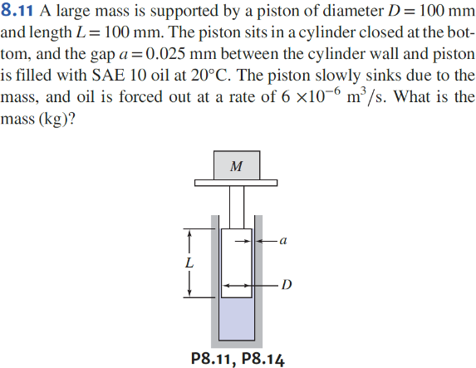
Flow between stationary plates:
$$V_{ave}=\frac{Q}{aπD} → Re=\frac{aV_{ave}}{v}$$
$$\frac{Q}{l}=\frac{a^{3}∆p}{12μL}$$
$$∆p→F→m$$
Solution:
$$Re=\frac{aV_{ave}}{v}=\frac{a\frac{Q}{aπD}}{v}=\frac{Q}{vπD}=\frac{\left(6×{10}^{-6} m^{3}/s\right)}{\left(1.1×{10}^{-4} m^{2}/s\right)×π×\left(100 mm\right)}=0.174$$
$$\frac{Q}{l}=\frac{a^{3}∆p}{12μL}⇒∆p=\frac{12μLQ}{la^{3}}=\frac{12×\left(1×{10}^{-1} N∙s/m^{2}\right)×\left(100 mm\right)×\left(6×{10}^{-6} m^{3}/s\right)}{\left(100 mm\right)×π×{\left(0.025 mm\right)}^{3}}=146.7 MPa$$
$$\frac{mg}{\frac{πD^{2}}{4}}=∆p$$
$$m=\frac{∆p\frac{πD^{2}}{4}}{g}=\frac{\left(146.7 MPa\right)×\frac{π×{\left(100 mm\right)}^{2}}{4}}{\left(9.8 m/s^{2}\right)}=1.18×{10}^{5} kg$$

Problem 8.18
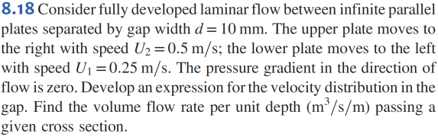
$$\frac{dP}{dx}=0 → \frac{dτ}{dy}=μ\frac{d^{2}u}{dy^{2}}=0$$
$$\frac{d^{2}u}{dy^{2}}=0 → u\left(y\right), u\left(0\right)=-U_{1}, u\left(d\right)=U_{2}$$
$$Q=\int{u dA}=b\int_{0}^{d}{u dy} → \frac{Q}{b}=???$$
Solution:
$$\frac{dP}{dx}=0 → \frac{dτ}{dy}=μ\frac{d^{2}u}{dy^{2}}=0$$
$$\frac{d^{2}u}{dy^{2}}=0 → u\left(y\right)=C_{1}y+C_{2}, u\left(0\right)=-0.25 m/s, u\left(0.01 m\right)=0.5 m/s$$
$$⟹\left\{\begin{aligned}C_{2}=-0.25 m/s \\ C_{1}=75 s^{-1}\end{aligned}\right.$$
$$⟹u\left(y\right)=75y-0.25$$
$$Q=\int{u dA}=b\int_{0}^{d}{u dy}$$
$$→\frac{Q}{b}=\int_{0}^{d}{u dy}=\int_{0}^{0.01}{\left(75y-0.25\right) dy}={\left.\left(\frac{75}{2}y^{2}-0.25y\right)\right|}_{0}^{0.01}=0.00125 m^{3}/s/m$$

Problem 8-39
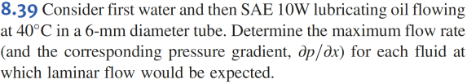
Solution:
Water:
$$Re=\frac{ρ\overline{V}D}{μ}$$
$$Q=\frac{{Re}_{crit}πvD_{1}}{4}=\frac{\left(2300\right)×π×\left(6.59×{10}^{-7} m^{2}/s\right)×\left(6 mm\right)}{4}=7.14×{10}^{-6} m^{3}/s$$
$$Q=-\frac{πR^{4}}{8μ}\frac{∂p}{∂x}$$
$$\frac{∂p}{∂x}=-\frac{8μQ}{πR^{4}}=-\frac{128μQ}{πD^{4}}=-\frac{128×\left(6.53×{10}^{-4} N∙s/m^{2}\right)×\left(7.14×{10}^{-6} m^{3}/s\right)}{π×{\left(6 mm\right)}^{4}}=-146.63 Pa/m$$
SAE:
$$Re=\frac{ρ\overline{V}D}{μ}$$
$$Q=\frac{{Re}_{crit}πvD_{1}}{4}=\frac{\left(2300\right)×π×\left(3.8×{10}^{-5} m^{2}/s\right)×\left(6 mm\right)}{4}=4.12×{10}^{-4} m^{3}/s$$
$$Q=-\frac{πR^{4}}{8μ}\frac{∂p}{∂x}$$
$$\frac{∂p}{∂x}=-\frac{8μQ}{πR^{4}}=-\frac{128μQ}{πD^{4}}=-\frac{128×\left(3.4×{10}^{-2} N∙s/m^{2}\right)×\left(4.12×{10}^{-4} m^{3}/s\right)}{π×{\left(6 mm\right)}^{4}}=-4.40×{10}^{5} Pa/m$$

Problem 8.40
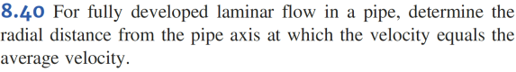
$$\overline{V}=\frac{Q}{A}=-\frac{R^{2}}{8μ}\frac{δp}{δx}$$
$$u=-\frac{R^{2}}{4μ}\frac{δp}{δx}\left[1-{\left(\frac{r}{R}\right)}^{2}\right]$$
Solution:
$$\overline{V}=\frac{Q}{A}=-\frac{R^{2}}{8μ}\frac{δp}{δx}$$
$$u=-\frac{R^{2}}{4μ}\frac{δp}{δx}\left[1-{\left(\frac{r}{R}\right)}^{2}\right]$$
$$-\frac{R^{2}}{4μ}\frac{δp}{δx}\left[1-{\left(\frac{r}{R}\right)}^{2}\right]=-\frac{R^{2}}{8μ}\frac{δp}{δx}$$
$$\left[1-{\left(\frac{r}{R}\right)}^{2}\right]=\frac{1}{2}$$
$${\left(\frac{r}{R}\right)}^{2}=\frac{1}{2}$$
$$r=\frac{R}{\sqrt{2}}$$

